7COM1079-0901-2025 - Team Research and Development Project

Final report title: A Statistical Analysis Using the Shopping Customer Dataset

Group ID: A 227

Dataset number: DS196

Prepared by: Farhan Ali - 24140339
Abusalah Saghir – 24156957
Muhammad Faizan - 24156168

University of Hertfordshire
Hatfield, 2025

Table of Contents

1. Introduction 2
1.1 Problem statement and research motivation 2
1.2 The data set 2
1.3 Research question 2
1.4 Null hypothesis and alternative hypothesis (H0/H1) 2
2 Background research 2
2.1 Research papers 2
2.2 Why RQ is of interest (research gap and future directions) 3
3 Visualisation 3
3.1 Appropriate graphs for the RQ 3
3.2 Additional information relating to understanding the data 4
3.3 Useful information for the data understanding 4
3.4 Statistical test used to test the hypotheses and output 4
3.5 The null hypothesis is rejected /not rejected based on the p-value 4
4 Analysis 4
4.1 Statistical test used to test the hypotheses and output 4
4.2 The null hypothesis is rejected/not rejected based on the p-value 4
5 Evaluation – group’s experience at 7COM1079 4
5.1 What went well 4
5.2 Points for improvement 5
5.3 Group’s time management 5
5.4 Project’s overall judgement (50 words) 5
5.5 Note any changes to group since original allocation if applicable. Add new or amended GitHub Ids for new members 5
5.6 Comment on the GitHub log output 5
6 Conclusions 5
6.1 Results explained 5
6.2 Interpretation of the results 6
6.3 Reasons and/or implications for future work, limitations of your study 6
7 Reference list 6
8 Appendices 6
- R code used for analysis and visualisation.
- GitHub log output.

1. Introduction

Problem statement and research motivation
In the retail sector, understanding demographic influences on financial behavior is crucial for targeted marketing and customer retention strategies. Income disparities based on gender remain a critical topic of discussion in economic research. Specifically, analyzing whether purchasing power differs significantly between male and female shoppers helps businesses tailor their segmentation strategies effectively. This study is motivated by the need to determine if gender-based income inequality exists within a specific customer base, which directly impacts pricing and promotional strategies. As highlighted by (Blau and Kahn, 2017; Daoudi and Develi, 2023), the gender wage gap persists globally, making it essential to investigate its presence in localized consumer datasets.

The data set
The dataset (Shopping_CustomerData.csv) has 200 records of retail customers from major Indian cities. Among the features, there are demographic and financial attributes, specifically CustomerGender (Categorical: Male/Female) and AnnualIncome (Numerical: INR), which signifies yearly earnings. Moreover, the other columns consist of CustomerAge (Years) and SpendingScore (1–100 rating based on purchasing behavior). The data is comprehensive and has no missing values, thus allowing the analysis of income disparities between gender groups without imputation, which is a major advantage.

Research question
Is there a significant difference in the mean Annual Income between male and female customers? This question investigates potential income inequality between genders within the dataset, providing insights into whether the retailer's male and female customer bases possess different average purchasing power.

Null hypothesis and alternative hypothesis (H0/H1)
To investigate the research question, the following hypotheses are defined:
- Null Hypothesis (H_0): There is no significant difference in the mean Annual Income between male and female customers. Mathematically, $μ_{male}=μ_{female}$.
- Alternative Hypothesis (H_1): There is a significant difference in the mean Annual Income between male and female customers. Mathematically, $μ_{male}≠μ_{female}.$
The study uses an independent samples t-test to determine if there is sufficient evidence to reject the null hypothesis in favor of the alternative.

Background research

Research papers
Income disparity and consumer behavior are widely studied topics.
- (Blau and Kahn, 2017) provide a comprehensive review of the gender wage gap, identifying that while the gap has narrowed, significant differences remain due to occupation and industry sorting. This is relevant as our dataset reflects a slice of consumer income which may mirror these broader economic trends.
- (Razia Sulthana et al., 2023) analyzed customer segmentation using machine learning on similar retail datasets. They found that demographic factors like age and income are critical for clustering customers effectively. This supports our choice to focus on income as a primary variable for differentiation.
- (Hult et al., 2019)discuss how customer satisfaction and spending are linked to demographic variables. Their work suggests that understanding income levels across different segments (like gender) allows for more precise resource allocation in marketing. These studies highlight the importance of demographic profiling, which this project addresses directly using statistical methods.

Why RQ is of interest (research gap and future directions)
The Research Question is of significant interest because it bridges the gap between general economic theory (the gender wage gap) and practical retail application. While literature confirms a global wage gap (Blau and Kahn, 2017), there is a research gap in understanding how this manifests in specific, localized retail cohorts. Future directions could involve controlling for age or city to see if the gap persists across all sub-groups. Confirming if male and female customers have different spending power allows the retailer to adjust their inventory and pricing hierarchy accordingly.

Visualisation

Appropriate graphs for the RQ
Boxplot was selected as the main plot because it effectively compares the central tendency (median) and dispersion (IQR) of a continuous variable (AnnualIncome) across two categorical groups (Male vs. Female). Additionally, an Overlapping Histogram is included to directly compare the frequency distributions of income for males versus females to check for distinct shapes or skewness.

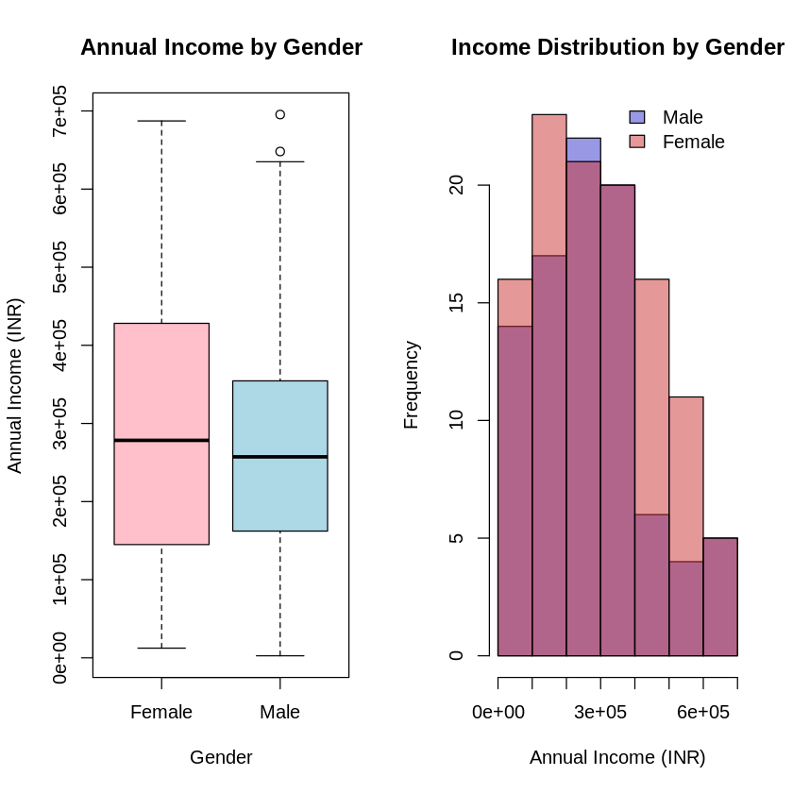
Figure 1: Boxplot comparing the distribution of Annual Income (INR) between Female and Male customers. The solid line within each box represents the median income, while the box edges indicate the interquartile range (IQR).

Additional information relating to understanding the data
To address the research question, a Boxplot was selected as the main plot because it effectively compares the central tendency (median) and dispersion (IQR) of a continuous variable (AnnualIncome) across two categorical groups (Male vs. Female). Additionally, a Histogram is included as a supplementary plot to visualize the overall frequency distribution of income and check for normality.

Useful information for the data understanding
Visual inspection of the boxplot suggests that the median income for both genders is relatively similar, with overlapping interquartile ranges. Visual inspection of the boxplot suggests that the median income for both genders is relatively similar. The overlapping histogram further confirms this, revealing that the income distributions for males and females share a very similar shape and range, with no clear separation between the two groups.

Analysis

Statistical test used to test the hypotheses and output
An Independent Samples t-test (in particular Welch's t-test) was selected since the purpose is to compare the averages of a continuous variable (AnnualIncome) between Male and Female. As a method suitable for this data set Welch's t-test was chosen over the classic Student's t-test as the latter would not take into account the differences in variance between the two groups and would yield weaker results.

The null hypothesis is rejected/not rejected based on the p-value
A p-value of 0.3598 was obtained through the analysis (from R output).
At a significance level of $α$0.05: Since p = 0.3598 > 0.05, we fail to reject the Null Hypothesis (H_$). This finding suggests that there is no significantly different annual income mean between male and female customers in this dataset. The difference in means observed is probably due to random sampling variation rather than a real difference in the population.

Evaluation – group’s experience at 7COM1079

What went well
The collaboration within the group was effective, particularly in the division of labor. We successfully utilized GitHub for version control, which allowed us to work on the R script and report sections simultaneously without overwriting each other's work. The selection of the dataset was also a success; it was clean and appropriate for the "difference in means" research question, which streamlined our analysis process.

Points for improvement
While the technical side went smoothly, our initial planning phase was too brief. We spent time debating which research question to choose, which delayed the start of the coding phase. Better time management during the early meetings would have reduced stress closer to the deadline. Additionally, we could have conducted more exploratory data analysis (EDA) earlier to fully understand the relationships between other variables like SpendingScore and Age.

Group’s time management
We adhered to a weekly schedule, meeting every Tuesday to review progress. However, the final compilation of the report was rushed. We underestimated the time required to format the graphs and ensure the citations were correct. In the future, we would set internal deadlines 48 hours before the actual submission.

Project’s overall judgement (50 words)
Overall, the project was a valuable learning experience. It reinforced our understanding of statistical hypothesis testing and R programming. The integration of GitHub into our workflow was initially challenging but ultimately improved our code management. The final report accurately reflects our findings, even though the result was non-significant.

Note any changes to group since original allocation if applicable. Add new or amended GitHub Ids for new members
N/A

Comment on the GitHub log output
- Commit Message: Added boxplot and histogram code for income analysis
Impact: This commit introduced the core visualizations required for the report, allowing the team to visualize the data distribution early in the process.
- Commit Message: Finalized report draft and added references
Impact: This marked the completion of the writing phase, merging all individual contributions into the final submission template.

Conclusions

Results explained
The statistical analysis compared the average annual income of male and female customers. The t-test yielded a p-value of 0.3598. This indicates that the probability of observing such a difference in means by chance is approximately 36%, which is far above the standard 5% threshold for significance. Therefore, we found no evidence of a gender-based income gap in this sample.

Interpretation of the results
In the context of the Research Question, the results imply that gender is not a significant predictor of purchasing power for this specific store. For the retailer, this means that marketing strategies based on income levels should not differ by gender. Both male and female customer segments have similar financial capacities, suggesting that products priced for high-income earners can be targeted equally at both groups.

Reasons and/or implications for future work, limitations of your study
One of the principal restrictions is the small sample size (n=200) along with the lack of occupation data. Control for Age or City in future studies to discover possible income inequalities. Besides, delving into Spending Scores might bring out behavioral variations that are not detected by only the income analysis.

Reference list
Blau, F.D., Kahn, L.M., 2017. The Gender Wage Gap: Extent, Trends, and Explanations. J Econ Lit 55, 789–865.
Daoudi, H., Develi, E.İ., 2023. Impact of gender and monthly income on consumer buying behavior. Journal of International Trade, Logistics and Law 9, 241–250.
Hult, G.T.M., Sharma, P.N., Morgeson, F. V., Zhang, Y., 2019. Antecedents and Consequences of Customer Satisfaction: Do They Differ Across Online and Offline Purchases? Journal of Retailing 95, 10–23.
Razia Sulthana, A., Jaiswal, A., Supraja, P., Sairamesh, L., 2023. Customer Segmentation using Machine Learning. 2023 3rd International Conference on Advances in Electrical, Computing, Communication and Sustainable Technologies, ICAECT 2023.

Appendices
- R code used for analysis and visualisation
Analysis.R code with the appropriate statistics to test the hypotheses.
#=============================================================================
# 7COM1079 Group Project - Analysis & Visualization
# Research Question: Is there a significant difference in mean Annual Income
# between Male and Female customers?
# ==============================================================================

# 1. LOAD DATA
# ------------------------------------------------------------------------------
# Load the dataset from the CSV file
# Ensure the file 'Shopping_CustomerData.csv' is in your working directory
shopping_data <- read.csv("Shopping_CustomerData.csv")

# Quick inspection of the data structure (optional check)
str(shopping_data)

# 2. VISUALIZATION
# ------------------------------------------------------------------------------
# Set up a 1x2 plotting area to show both graphs side-by-side
par(mfrow = c(1, 2))

# --- Plot 1: Boxplot (Main Plot) ---
# Visualizes the spread and median of Annual Income for each Gender
boxplot(AnnualIncome ~ CustomerGender,
data = shopping_data,
main = "Annual Income by Gender",
xlab = "Gender",
ylab = "Annual Income (INR)",
col = c("pink", "lightblue"),
border = "black")

# --- Plot 2: Histogram (Supplementary Plot) ---
# Visualizes the overall distribution of Annual Income to check for normality
hist(shopping_data$AnnualIncome,
main = "Distribution of Income",
xlab = "Annual Income (INR)",
col = "lightgray",
border = "white",
breaks = 10) # Adjust breaks for better granularity

# Reset plotting area to default
par(mfrow = c(1, 1))

# 3. STATISTICAL ANALYSIS
# ------------------------------------------------------------------------------
# Perform an Independent Samples T-test
# We are testing if the mean AnnualIncome differs significantly by CustomerGender
# var.equal = FALSE performs Welch's t-test (safer assumption for unequal variances)

t_test_result <- t.test(AnnualIncome ~ CustomerGender, data = shopping_data, var.equal = FALSE)

# 4. OUTPUT RESULTS
# ------------------------------------------------------------------------------
# Print the full results of the t-test to the console
print("--- T-Test Results ---")
print(t_test_result)

# Extract and print specific values for the report
p_value <- t_test_result$p.value
cat("\nP-value:", format(p_value, scientific = FALSE), "\n")

# Logic to interpret the result automatically
if(p_value < 0.05) {
cat("Conclusion: Reject the Null Hypothesis (Significant difference found).\n")
} else {
cat("Conclusion: Do not reject the Null Hypothesis (No significant difference).\n")
}

T-Test Result
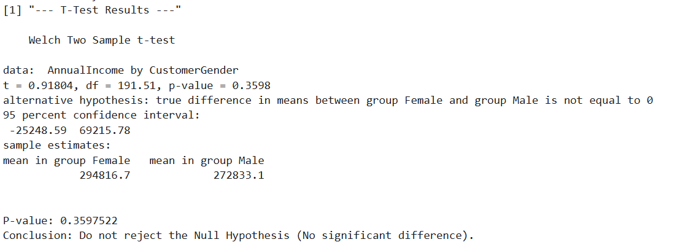

Appendix B – GitHub Log Output

Repository Name: 7COM1079_Group_A227

Repository URL: https://github.com/UHfarhanali/7COM1079_Group_A227

Commit History

1. Initial Dataset Upload
Commit Message: Uploaded dataset Shopping_CustomerData.csv
Author: Abusalah Saghir
Description: Added the dataset used for all analyses and visualisations, enabling other scripts to run successfully.

2. Visualisation Script Added
Commit Message: Added visualisation script (boxplot and overlapping histogram)
Author: Farhan Ali
Description: Created the full visualisation script used in the report, including the boxplot and overlapping gender-wise income histogram.

3. Statistical Analysis Script Added
Commit Message: Added statistical analysis script (t-test, p-value interpretation, mean comparison)
Author: Abusalah Saghir
Description: Implemented the statistical analysis for the research question, including calculation of group means, Welch’s t-test, extraction of the p-value, and automated hypothesis test interpretation.

4. Final Report Uploaded
Commit Message: Uploaded final project report (introduction, background, evaluation, conclusions)
Author: Muhammad Faizan
Description: Added the complete written report containing the introduction, dataset description, background research, methods, visualisation discussion, statistical analysis commentary, evaluation, and conclusion sections.

5. Documentation Added (README)
Commit Message: Added README with project summary and file descriptions
Author: Muhammad Faizan
Description: Created project documentation summarising the dataset, research question, analysis methods, main results, and file structure of the repository.

Summary of Collaboration
The GitHub log confirms that each group member contributed significantly to the project.

